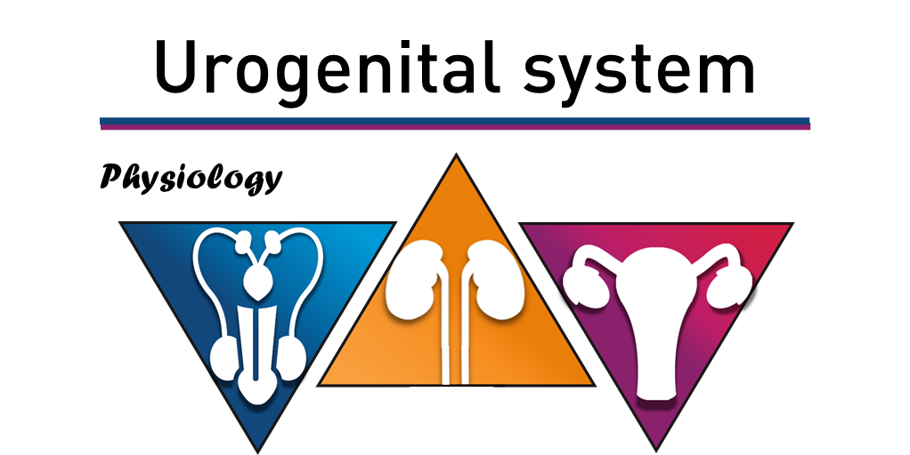

-سليم الخريشة

-مؤيد الشافعي

-محمود الحربي

-5

* **Contraceptive methods:**

**Notes on the table:**

-These statistics are made in the USA ( (وهم أكثر الناس تَدَيُّنًا

-**Pills** are exogenous hormones that the woman takes to prevent pregnancy. Some people say that pills may cause breast cancer and uterine cancer and other cancers but this is not proven to be true. If they happen to cause cancer, the reason will be that the pills provide the body with high concentrations of hormones and we all know that normally the concentrations of hormones are very minute in the body.

-**Female sterilization** is by fallopian tubes ligation.

-**Male sterilization is by vasectomy** (removal or ligation of the vas deferens) it is not widely used.

-The doctor said that the ligations are reversible(وأي حدا بيحكي غير هيك مش صحيح, لانه العلم تطور وصرنا نقدر نعمل كل شي).

-‘Diaphragm or sperm barrier’ works by blocking the sperms (putting barriers in their way).

-‘Spermicides’ which **chemically kill sperms**.

-‘Rhythm’ is the avoidance of intercourse during the **unsafe period** which is the time near the ovulation.

-The intrauterine device prevents implantation. It can be used from 1-5 years. Also, It can be removed by the doctor if the woman does not need it anymore.

-From **“estimated use %”** in the table, we find that the pills are the most used method (because they are easy to use) and the intrauterine device is the least used method.

-The doctor read the “accidental pregnancy in year 1 percentages” from the table.

-**The method with the most side effects is the pills and the method with the least side effects is the intrauterine device**.

**\*Pills method**

**- There are 5 types. Compare them with these categories when studying: composition, administration, time of action and mode of action.**

1-**Combined oral contraceptive pills (COCP)**: they contain synthetic progesterone and estrogen. They are administered orally. These pills are taken daily for 21 days and they work by preventing ovulation.

2-**Progesterone-only pills**: they contain synthetic progesterone only. They are administered orally. They are taken daily without a break between packs, and must be taken at the same time every day. These work by preventing ovulation.

3-**Emergency pills**: they contain high doses of synthetic estrogens and progesterone. They are administered orally. They must be taken within 72 hours of sexual intercourse if no other contraception was used. They work by inhibiting implantation.

4-**Depot (contraceptive injection):** they contain synthetic progesterone. They are administered intramuscularly by injection and they last for 8-12 weeks. They work by suppressing ovulation.

5-**Implants**: they contain synthetic progesterone. They are implanted under the skin. They last up to 5 **years**. They work by suppressing ovulation.

**-All of them prevent ovulation except the emergency pills.**

-Pills effectiveness is very high; it can reach up to (95-100) %.

**\*Rhythm method**

**-** The regular uterine and ovarian cycles take 28 days to finish. Few women have less than 28 days duration and few women have more than 28 days duration and both are completely **normal if their cycles are regular(all cycles have the same duration).** So a woman shouldn’t be afraid if her cycle lasts for 24 days for example. The abnormality is when the normal duration is disrupted. For example, if the 24 days woman had a cycle that lasted for 28 days; then she should be concerned.

-So women’s cycles range from 21 days to 35 days. (In very very rare cases, some women may have a cycle that lasts for 42 days).

-First 4-5 days of the cycle **are menstrual phase**.

**-How to use the rhythm method for a women with 28 days cycle ?**

-The sperm can last for 2 days in the female reproductive system and be able to fertilize the ovum. (From the internet: the sperm can last up to 5 days).

-Ovulation happens at the 14th day of the cycle.

-So, people who want to have children should have sexual intercourse 3 days prior the ovulation (as the sperm can last for 2 days, and as the doctor said; we give an extra spare day).

-Also, the ovum may be able to receive sperm for 2 days (maybe 3) after it is ovulated. So, people who want to have children can also have sexual intercourse two days after ovulation.

-So, we conclude that ***the unsafe period*** is from day 11 to day 17 (14±3) of the cycle. This means that, couples that don’t want children should avoid this period.

-***The safe period*** is from day 17 to 28 and no pregnancy happens at this time.

-The time from day 4 to day 11 is ***the possibly safe period*** and pregnancy may or may not happen.

Ovulation **always** indicates that the cycle has a remaining 14 days. For example, if ovulation happened at day 18; this means that there are 14 days remaining for the cycle which means that the cycle is 32 days for this woman. (Remember that not all women have a 28 day cycle). So with this, you can know at what day the ovulation happens by using the equation “X+14=duration of the cycle” (  
the doctor said that you will not find this equation in any textbook). If the cycle is 24 days; you subtract 14 to know when the ovulation happens (Day 10 in this case). Now to know the unsafe period, you do a ±3 to the ovulation day. So the unsafe period is 10±3 which is from day 7 to day 13. Now, the safe period is from day 13 till the end of the cycle (13 to 24). The possibly safe period is from the end of the menstrual phase till day 7.

Another example: if the cycle is 34 days:

The ovulation day is: 34-14=20

The unsafe period is: 20±3=17 to 23

The safe period is: 23 to 34

The possible safe period is: from the end of menstrual phase to day 17

* **Female Fertility**

- Infertility affects 1 out of 5 women in the US.

-Understanding female endocrinology, anatomy and physiology is essential to gain insight and be able to solve this major health problem (infertility).

-**Several factors may cause infertility:**

1. Environmental factors. 2. Disorders of the central nervous system. 3. Hypothalamic diseases. 4. Pituitary disorders

5. Ovarian abnormalities.

**- These can interfere with follicular development and/or ovulation.**

-If a normal ovulation occurs; structural, pathological and endocrine problems associated with the **uterus and/or** **oviduct** can prevent fertilization by depleting the transport or implantation of the embryo and ultimately interfere with the establishment or maintenance of pregnancy.

-However, the most common cause of female sterility is failure to ovulate.

* **Placenta**

-When stem cell therapy was introduced, the first cells used in the therapy were placental cells.

-The placenta secretes many hormones as we will see below.

**The fetoplacental unit and steroidogenesis:**

-To understand the figure: on the left is the maternal compartment of the placenta. The figure shows things that pass from the mother to the placenta and vice versa. On the right is the fetal compartment of the placenta and the figure shows things that pass from the fetus to the placenta and vice versa. In the middle is the placenta; and the figure shows the production of hormones in it and it also shows the substrates for each substance. For example, pregnenolone is shown to have two sources; one from the maternal and one from the fetal. It also shows that pregnenolone can pass to the fetal compartment but it doesn’t pass into the maternal compartment (just look at the arrows). The following video is very helpful and short: <https://www.youtube.com/watch?v=mrRcgolgWWU>

-As you see in the figure, **the placenta produces progesterone**. You can see that its substrates come from the mother and the fetus.

-Progesterone passes into the fetus and the mother.

-**The placenta also produces estrone and estriol**, the most potent female hormones. As you can see, their substrate (Dehydroepiandosterone) also comes from both the fetus and the mother. This substrate produces androstenedione and testosterone.

-Estrone and estriol pass into the mother and the fetus.

-Estriol is important for the normal health of the fetus. Deficiency in estriol means that the health of the fetus is not good.

-During pregnancy, **not only the placenta produces chemicals. Blastocysts and the endometrium** also produce many chemicals (proteins, hormones, enzymes…). The most important hormone produced by the blastocysts is the human chorionic gonadotropin.

-**Human chorionic gonadotropin** is one of the most important factors secreted by the blastocysts, both preimplantation and postimplantation. Besides rescuing the corpus luteum, hCG acts as an immunosuppressive agent, has growth-promoting activity, and acts as an autocrine growth factor that promotes trophoblast growth and placental development. Thus, hCG may have a role in the adhesion of the trophoblast to the epithelia of the endometrium. hCG has protease activity, and hCG levels are high in the area where the trophoblast faces the endometrium. {The underlined are the functions of the hCG}

-Also, remember that this hormone is important for fetal adrenal gland and testis **as it works instead of LH to produce testosterone.**

**Placental hormones:**

-All these hormones are produced by the placenta. They are two types, either steroid hormones or peptide hormones and neuropeptides.

-The most important hormone is the human chorionic gonadotropin. This hormone’s function is the growth of the corpus luteum, as we said. The growth of corpus luteum means that there is pregnancy. So this hormone can be used to indicate the presence of pregnancy.

-This hormone can be tested from the plasma and from the urine to **indicate pregnancy.**

-**There are 5 hormones that play a role in the conversion of glucose to fatty acids and ketones** **(the energy sources for the fetus and the placenta). These hormones are**:

1. Human chorionic gonadotropin (hCG)

2. Human placental lactogen (hPL: hPL1 and hPL2), also known as Human chorionic somatomammotropins 1 and 2 (hCS1 and hCS2).(they are 2)

3. Placental- variant growth hormone

4. Prolactin

-These hormones **provide the energy sources for the fetus and placenta** (or you can say the fetoplacental unit) as they use fatty acids and ketones as energy sources. They also store them as fuel.

-**Human placental lactogens have another function: they promote the development of the maternal mammary glands during pregnancy**.

-These 5 hormones are produced by the same cells, but their pattern of secretion is different indicating the possibility of control by different regulatory mechanisms.

-In the first 3 months of pregnancy, women have **morning sickness**. The cause of this is the high concentrations of the human chorionic gonadotropin hormone and thyroxin at the beginning of pregnancy. Actually, **thyroxin** must be high in concentration because it is very important in the development of the skeleton and the CNS.

* **Fertilization**

**-**As you remember, fertilization occurs at fallopian tube. The fallopian tubes transport the germ cells in two opposite directions: 1-sperm are transported from the uterus toward the fertilization site 2-the zygote is transported from the fertilization site towards the uterus.

-This movement in two opposite directions **requires** coordination between **smooth muscle contraction, ciliary movement and fluid secretion**. All of those are under hormonal and neural control.

-The most important factor in the movement of the zygote from the fertilization site towards the uterus for implantation (after about 7 days fertilization) is the **peristaltic movement**. When the zygote is big enough and reaches a certain site during its movement, it will cause the smooth muscles behind it to contract and the ones in front of it to relax (this is how the peristaltic movement happens).

**"وَآخِرُ دَعْوَاهُمْ أَنِ الْحَمْدُ لِلَّهِ رَبِّ الْعَالَمِينَ"**